**Student Grading Application CP212**

**Ozair Khan**

**Summary:**

Grading application that utilizes excel, access and word for interactive student data representation regarding course-based marks. The goal of this application is to make data access and presentation better.

**Different Functions/Operations:**

* Import Data (Exhibit A)
  + Imports data from a user chosen access database and displays data in excel in easy-to-read method. Results will be displayed in the **Students** sheet
* List Courses (Exhibit B)
  + Takes user input for a course as well as a chosen calculation to perform (e.g. Cumulative, assignment 1, midterm exam, etc…). Results will be displayed in the **Grades** and **Calculations** sheet.
* Generate Report (Exhibit A)
  + Generates a word document with a summary of important data relevant for the user. Results will be displayed in word document called **Automated Output**

**General Instructions:**

* Start by selecting the home page running the main menu button
* Select one of the 3 operations (which will then open up another user Form or file dialog box)
* For all operations users must select a valid access database for data input.
* For the generate report additional input is needed to determine where to save the report document

**Exhibits/Images**

* Exhibit A

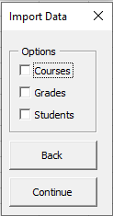

* Exhibit B

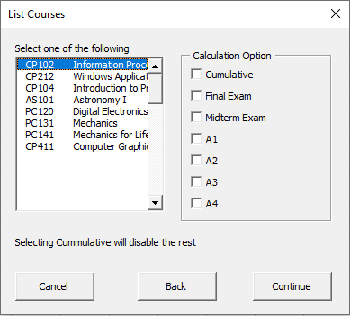

* Exhibit C

